24CSI024- DATA STRUCTURE AND ALGORITHMS
UNIT-1 INTRODUCTION TO DATA STRUCTURE AND ALGORITHMS

NAME: HARIHARAN B
ROLL NO: 25BAD030

Experiment: Squaring a Sorted Array Using Two-Pointer Technique

Aim:
To write a C program to square each element of a sorted array and return the squared values in non-decreasing order using the Two-Pointer technique.
Algorithm:
1. Read the number of elements N.
2. Read the sorted array.
3 Initialize:
• left = 0
• right = N - 1
• pos = N - 1
4.Compare the absolute values of arr[left] and arr[right].
5. Square the larger absolute value and store it in result[pos].
6. Move the corresponding pointer (left++ or right--).
7. Decrement pos.
8. Repeat until left > right.
9. Print the result array.

CODE:
#include <stdio.h>
#include <stdlib.h>

int main() {
int N;
scanf("%d", &N);
int arr[N], result[N];

// Read the sorted array
for (int i = 0; i < N; i++) {
scanf("%d", &arr[i]);
}

int left = 0;
int right = N - 1;
int index = N - 1;

// Two-pointer approach
while (left <= right) {
if (abs(arr[left]) > abs(arr[right])) {
result[index] = arr[left] * arr[left];
left++;
} else {
result[index] = arr[right] * arr[right];
right--;
}
index--;
}

// Print the sorted squared array
for (int i = 0; i < N; i++) {
printf("%d", result[i]);
if (i != N - 1)
printf(" ");
}

return 0;
}

OUTPUT:
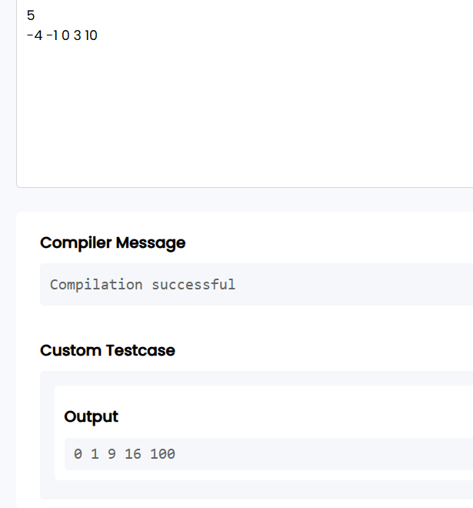

Result:
Thus, the C program to square the elements of a sorted array and produce the squared values in sorted order using the Two-Pointer technique was implemented and executed successfully.

Experiment: Cumulative Resource Consumption Using Prefix Sum

Aim:
To write a C program to compute the cumulative running sum (Prefix Sum) of an array.
Algorithm:
1. Read the number of elements N.
2. Read the array elements.
3. Create a prefix sum array.
4. Set prefix[0] = arr[0].
5. For each element from index 1 to N-1, compute:
o prefix[i] = prefix[i-1] + arr[i]
6. Print the prefix sum array.

CODE:

#include <stdio.h>
int main() {
int N;
scanf("%d", &N);
int arr[N];
long long prefix[N];

// Read the array
for (int i = 0; i < N; i++) {
scanf("%d", &arr[i]);
}

// Compute prefix sum
prefix[0] = arr[0];
for (int i = 1; i < N; i++) {
prefix[i] = prefix[i - 1] + arr[i];
}

// Print prefix sum array
for (int i = 0; i < N; i++) {
printf("%lld", prefix[i]);
if (i != N - 1)
printf(" ");
}

return 0;
}

OUTPUT:

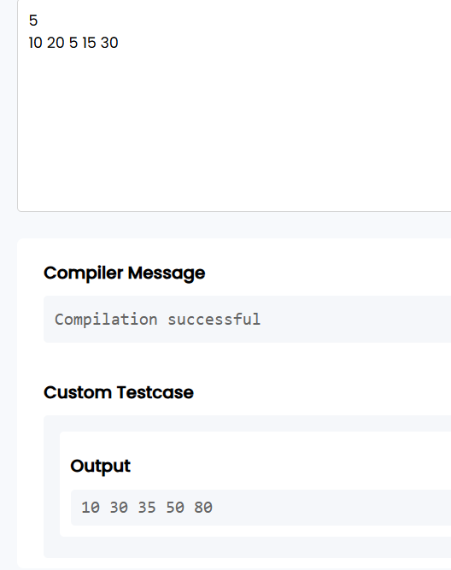

RESULT:
Thus, the C program to compute the cumulative running sum (Prefix Sum) of an array was implemented and executed successfully.

Experiment: Grouping Active Sectors Using Fixed-Size Sliding Window

Aim:

To write a C program to find the minimum number of swaps required to bring all 1s together using the Fixed-Size Sliding Window technique.

Algorithm:
Read the number of elements N.
Read the binary array.
Count the total number of 1s and store it in count.
If count is 0 or 1, print Min Swaps: 0.
Count the number of 1s in the first window of size count.
Slide the window through the array and keep track of the maximum number of 1s in any window.
Calculate:
Minimum Swaps = count - maximum_ones
Print the minimum swaps.

CODE:

#include <stdio.h>
int main() {
int N;
scanf("%d", &N);
int arr[N];

// Read array
for (int i = 0; i < N; i++) {
scanf("%d", &arr[i]);
}

// Count total number of 1s
int countOnes = 0;
for (int i = 0; i < N; i++) {
if (arr[i] == 1)
countOnes++;
}

// If there are 0 or 1 ones, no swaps are needed
if (countOnes <= 1) {
printf("Min Swaps: 0");
return 0;
}

// Count number of 1s in the first window
int currentOnes = 0;
for (int i = 0; i < countOnes; i++) {
if (arr[i] == 1)
currentOnes++;
}

int maxOnes = currentOnes;

// Slide the window
for (int i = countOnes; i < N; i++) {
if (arr[i] == 1)
currentOnes++;
if (arr[i - countOnes] == 1)
currentOnes--;

if (currentOnes > maxOnes)
maxOnes = currentOnes;
}

// Minimum swaps
int minSwaps = countOnes - maxOnes;

printf("Min Swaps: %d", minSwaps);

return 0;
}

OUTPUT:

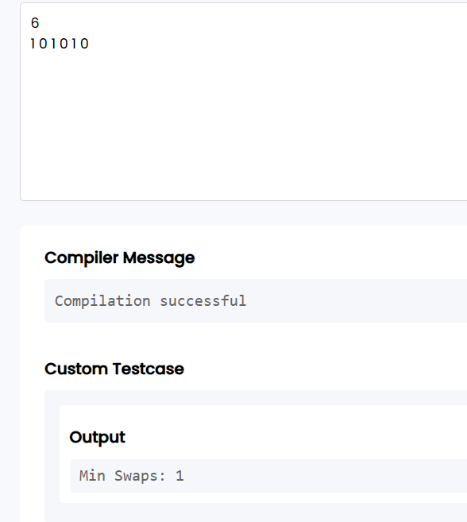
RESULT:

Thus, the C program to find the minimum number of swaps required to group all 1s together using the Fixed-Size Sliding Window technique was implemented and executed successfully.

Experiment: Maximum Task Window Within Budget Using Variable-Size Sliding Window

Aim:

To write a C program to find the maximum number of consecutive tasks whose total energy cost does not exceed the given limit using the Variable-Size Sliding Window technique.

Algorithm:
Read the values of N and P.
Read the array of energy costs.
Initialize:
start = 0
current_sum = 0
maxLength = 0
Traverse the array using the end pointer.
Add arr[end] to current_sum.
While current_sum > P, subtract arr[start] from current_sum and increment start.
Update maxLength with the maximum window size.
Print Max Length.

CODE:

#include <stdio.h>

int main() {
int N;
long long P;
scanf("%d %lld", &N, &P);

int arr[N];

// Read the array
for (int i = 0; i < N; i++) {
scanf("%d", &arr[i]);
}

int start = 0, maxLength = 0;
long long currentSum = 0;

// Sliding window
for (int end = 0; end < N; end++) {
currentSum += arr[end];

while (currentSum > P && start <= end) {
currentSum -= arr[start];
start++;
}

if (currentSum <= P) {
int length = end - start + 1;
if (length > maxLength)
maxLength = length;
}
}

printf("Max Length: %d", maxLength);

return 0;
}

OUTPUT:
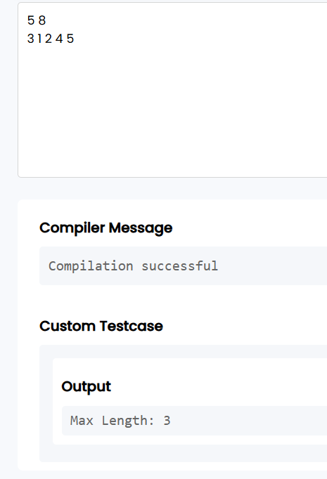

Result:

Thus, the C program to find the maximum number of consecutive tasks within the given energy limit using the Variable-Size Sliding Window technique was implemented and executed successfully.

EXPERIMENT 2: Sliding Window Maximum Peak (Monotonic Window Queue)

AIM:
To write a C program to find the maximum element in every sliding window of size K using the Monotonic Deque (Sliding Window Maximum) technique with O(N) time complexity.

ALGORITHMS:

- Start the program.
- Read the values of N (number of elements) and K (window size).
- Read the array elements.
- Create a deque using an array and initialize front = 0 and rear = -1.
- Traverse the array from i = 0 to N - 1.
- Remove indices from the front of the deque if they are outside the current window (deque[front] <= i - K).
- Remove indices from the rear of the deque while the corresponding array values are less than or equal to the current element.
- Insert the current index into the rear of the deque.
- If the window is completely formed (i >= K - 1), print the element at the front of the deque as the maximum of the current window.
- Repeat until all elements are processed.
- Stop the program.

CODE:
#include <stdio.h>
int main() {
int N, K;
scanf("%d %d", &N, &K);

int arr[N];
for (int i = 0; i < N; i++) {
scanf("%d", &arr[i]);
}

// Deque to store indices
int deque[N];
int front = 0, rear = -1;

for (int i = 0; i < N; i++) {

// Remove indices that are out of the current window
while (front <= rear && deque[front] <= i - K) {
front++;
}

// Remove smaller elements from the back
while (front <= rear && arr[deque[rear]] <= arr[i]) {
rear--;
}

// Add current index
deque[++rear] = i;

// Print maximum when the first window is complete
if (i >= K - 1) {
printf("%d", arr[deque[front]]);
if (i != N - 1)
printf(" ");
}
}

return 0;
}

OUTPUT:
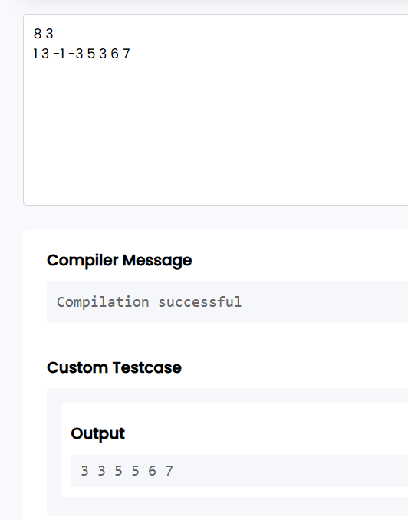
RESULT:
Thus, the C program to find the maximum element in every sliding window of size K using the Monotonic Deque technique was implemented successfully and the correct output was obtained with O(N) time complexity.

